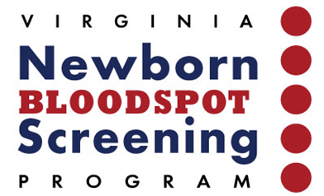
Implementation of Electronic Messaging for Newborn Screening - Benefits/ROI
- Improves the quality of submission data
  - Reduces time spent by hospital staff tracking down missing or eligible data from the sample submission card when requested by DCLS.
  - Eliminates opportunity for DCLS clerical staff to mis-key data during sample accessioning process, which could tie up hospital resources downstream.
  - Post-implementation data shows that hospitals that have moved to the electronic transmission of NBS orders see a 70% reduction in number of samples submitted with incorrect or missing data. This reduction greatly improves data quality which eliminates delays in sample processing and reduces time and effort for both hospital and NBS Program staff.
- All NBS sample demographic information is available to ensure testing can be performed as quickly as possible.
 | Before e-orders | After e-orders
Average DCLS processing time from sample receipt and accessioning through completion of data verification in LIMS | 4.8 hours | 1.4 hours
  - Speeds sample preparation on the hospital side (no more hand-writing of 50+ pieces of data on submission cards).
  - Speeds sample accessioning the DCLS side (no more keying of 50+ pieces of data).
- Provides an automatic tracking of samples and results.
  - If the electronic submission is sent but no physical sample arrives this provides an alert for DCLS to inquire about the pending sample. Likewise, the hospital can monitor to ensure results are returned as expected for all samples sent for screening.
- By receiving results electronically -
  - NBS results are available to healthcare professionals immediately upon completion of testing. No waiting for the printing of reports, the delivery of reports to the hospital and processing by hospital personnel.
 | Before e-results | After e-results
Average time from time of birth to time NBS results are available for review in hospital EMR | 10.8 days | 3.6 days
  - Hospital resources are no longer needed to receive, sort, scan or enter the NBS results into hospital EMR or distribute/file the paper copies the results.
- Improves patient care/outcomes –
  - Healthcare professionals can access NBS test results from the hospital EMR system an average of SEVEN days sooner than when hard copy reports have to be delivered, distributed and scanned. This could literally save the lives of newborns needing a rapid diagnosis and treatment!
For additional information please contact:
Emily Hopkins
VA/DCLS Director of Laboratory Operations
emily.hopkins@dgs.virginia.gov
Linoise Edassery
Technical Project Manager
DGS/Information Systems Services
Linoise.edassery@dgs.virginia.gov

